**Subject**: Proposal for Partnership between AWS Cloud Club - Philippines and SevenSeven (77) Company

Good day!

It is with great enthusiasm that we introduce **AWS Cloud Club - Philippines**, a nationwide initiative dedicated to fostering a vibrant and supportive community for students passionate about AWS and cloud technologies. Through our university chapters, we aim to build strong partnerships that empower students with the knowledge and skills needed to thrive in today’s dynamic tech industry.

At **AWS Cloud Club - Philippines**, we are committed to:

* **Promoting** a deeper understanding of cloud computing and its impact on modern technology.
* **Equipping** students with hands-on experience in AWS services, including Security, AI, Data Analytics, and Cloud Architecture.
* **Encouraging** real-world applications of cloud technology to prepare students for future careers.

**Why Partner with AWS Cloud Club - Philippines?**

At AWS Cloud Club - Philippines, we are building the next generation of tech leaders. Through our hands-on learning experiences, workshops, and real-world projects, we provide students with practical exposure to some of the most powerful and relevant cloud services offered by AWS, including Security, AI, Data Analytics, and Cloud Architecture. With our network of highly motivated, tech-savvy students, we believe that SevenSeven (77) Company and AWS Cloud Club - Philippines can form a powerful partnership that benefits both organizations for years to come.

**Our Vision for a Long-Term Partnership**

By joining forces with AWS Cloud Club - Philippines, SevenSeven (77) Company will have the unique opportunity to connect with a pool of talented students who are equipped with the latest industry trends and tools. This collaboration will help you tap into a growing talent pool with hands-on experience in cloud computing, AI, and other emerging technologies, ensuring a steady pipeline of highly skilled professionals for your company. Furthermore, it will allow SevenSeven to strengthen its position as a forward-thinking, tech-driven brand that supports the next wave of innovation in the tech industry.

**What We Offer in a Partnership**

As part of this long-term collaboration, AWS Cloud Club - Philippines can provide:

* **Exclusive Access to a Pool of Skilled Students**: With over 50+ members who have earned the AWS Foundational Badge and achieved AWS Certified Cloud Practitioner certification, you’ll have access to a network of highly capable and motivated students trained in cloud computing.
* **Event Sponsorship & Branding Opportunities**: Your brand will be prominently featured in events like our AWS Cloud Club Student Community Day, AWS Cloud Club workshops, and other major initiatives where we host expert speakers and tech sessions on the latest industry trends.
* **Career Development & Networking Events**: Through exclusive workshops, talks, and mentorship opportunities, your brand will be directly connected to future cloud computing professionals.
* **Collaborative Tech Events**: AWS Cloud Club regularly hosts groundbreaking events such as the AWS Cloud Club Generative AI Camp, AWS Learning Club seminars, and cloud-powered workshops, where SevenSeven can showcase its innovations and collaborate with the brightest young minds in the tech industry.

**Success Stories & Key Milestones**

We’ve had the privilege of organizing numerous impactful events and empowering our community that have bridged the gap between academia and industry. Notable events include:

* We currently have **22 active AWS Clubs** across Luzon, Visayas, and Mindanao, organizing technical seminars and workshops to enhance students' cloud computing skills.
* More than **50+ members** of our community have earned **AWS Foundational Badges** and achieved the **AWS Certified Cloud Practitioner** certification, showcasing their proficiency in fundamental cloud concepts.
* Our AWS Cloud Club – Philippines MeetUp has gathered a total **of 4,005 members**.
* **[You may add here more asiii]**

**Our Rapid Growth**

As one of the fastest-growing student tech communities in the country, we are proud to share some **key milestones**:  
  
**AWS Cloud Club Student Community Day Philippines 2024**

* Location: Bulwagang Balagtas, PUP Manila
* Date: April 17, 2024
* Highlights: Bridging the industry-academia gap with expert speakers such as **Dr. Werner Hans Peter Vogels** (CTO & VP of Amazon Web Services), Mr. Raphael Francis Quisumbing (AWS Community Hero), and Mr. Paul Sears (Senior Solutions Architect at AWS).

**AWS Cloud Club - National University Baliwag: Concept to Cloud**

* Location: National University Baliwag
* Date: June 7, 2024
* Highlights: Focused on containers, Kubernetes, prototyping skills, and networking with industry mentors.

**AWS Cloud Club - University of Cabuyao: Inauguration and Cloud Computing Seminar**

* Location: University of Cabuyao, Computer Laboratory 3
* Date: February 17, 2024
* Highlights: The first AWS Cloud Club chapter outside NCR, with insights from Mr. Isaeus B. Guiang, Regional Captain & AWS Community Builder.

**AWS Cloud Club - Haribon: re:Launch**

* Location**:** Bukod Tanging Bulwagan, PLM
* Date**:** February 25, 2025
* Highlights**:** An introduction to AWS cloud innovation, hands-on learning experiences, and a launchpad for aspiring cloud professionals to explore opportunities in cloud computing.

**AWS Archers Cloud Club - De La Salle Manila: Career Compass**

* Location**:** 21st Floor, Arthaland Century Pacific Tower, Taguig
* Date**:** June 5, 2024 (Wednesday)
* Highlights**:** Expert insights on building a tech career, strategic guidance for long-term success in cloud computing, and inspiring stories from professionals who have established themselves in the industry.

**AWS Cloud Club - Mapúa University Manila: Cardinals Assemble**

* Location: Smart Classroom, Mapúa University
* Date: October 4, 2024
* Highlights: Students explored AWS-powered solutions and career opportunities in cloud technology.

**AWS Cloud Club - Adamson University: FalCat’s Journey into the Cloud**

* Location**:** CS Gallery, Adamson University
* Date**:** October 2, 2024
* Highlights**:** Introduction to AWS opportunities and resources for students, guidance for beginners and those exploring cloud technologies, and access to a community of innovators and tech enthusiasts.

**AWS Cloud Club - TIP Manila: Generative AI Camp**

* Location: AWS Philippines, BGC, Taguig City
* Date: October 18, 2024
* Highlights: Hands-on workshops on advancements in AI technologies, generative AI models, and cloud-based AI tools.

**AWS Cloud Club - USTP: AWSOME HOUR**

* Location: USTP Campus
* Date: November 8, 2024
* Highlights: A workshop on Generative AI, exploring AI-powered solutions and AWS AI tools.

**AWS Cloud Club - PCU Cavite: AWScend Beyond Limits**

* Location: PCU Cavite, New Acad Bldg
* Date: March 3, 2025
* Highlights: Focused on cloud computing, innovation, and career development opportunities for students.

**AWS Learning Club - España: AWS in España**

* Location: Amazon Chime Livestream & Facebook Live
* Date: September 4, 2024
* Highlights: A live event catering to both beginners and experienced professionals, helping participants enhance their cloud skills.

**AWS Learning Club - Gordon College CCS: Diversifying Cloud Education and Opportunities**

* Location: AWS Philippines, Arthaland Pacific Century Tower, BGC, Taguig
* Date: March 28, 2025
* Highlights: Hands-on workshops and career discussions, with an emphasis on Women in Tech and networking sessions.

**AWS Learning Club - Legarda: The Carrot Cartel Gathering with AWS Learning Club**

* Location: AWS Philippines, BGC, Taguig City
* Date: October 30, 2024
* Highlights: A deep dive into AWS Cloud Technology and collaboration opportunities for students.

**AWS Learning Club - Spade: AWS Kick-Off 2024 – Charting New Horizons in Cloud Technology**

* Location: Interdisciplinary Research Building Conference, Cavite State University
* Date: November 26, 2024
* Highlights: Introduction to AWS cloud technologies and career opportunities for students at Cavite State University.

**AWS Learning Club - UP Baguio: In the Clouds, Above the Pines – A Jourey to Cloud Computing**

* Location: Teatro Amianan, UP Baguio
* Date: February 8, 2025
* Highlights: Connecting with expert speakers and learning about the impact of cloud computing on various industries.

**AWS Learning Club - UP Mindanao: Amazon Elastic Compute Cloud Workshop - Backbone of AWS**

* Location: ILC Room 7, Elias B. Lopez Hall, UP Mindanao, Davao City
* Date: October 28, 2024
* Highlights: Hands-on exploration of Amazon EC2, providing insights into cloud computing for developers and beginners.

**AWS Learning Club - UPHSL: Unlock the Power of the Cloud: Introduction to AWS & Career Opportunities**

* Location: Zoom
* Date: May 4, 2024
* Highlights: Introduction to AWS and career opportunities within the cloud computing industry.

**AWS Learning Club - USLS: AWS Community Day**

* Location: Santuario De Lasalle
* Date: November 16, 2024
* Highlights: Sessions on various cloud topics, networking with the cloud community, and insights into career paths in cloud computing.

**AWS Learning Club - Shaw in Partnership with ICPEP: Riding the Cloud, Roaring into AWS**

* Highlights: Introduction to AWS fundamentals and cloud deployment best practices.

**With the remaining clubs yet to establish and implement their own program!**

These are just a few examples of how our community is driving innovation and shaping the future of cloud computing. As a partner, you will have access to these initiatives and the chance to actively contribute to their success while building long-lasting relationships with future industry leaders.

**The Future of Cloud Computing – Together**

Our shared commitment to fostering innovation, learning, and talent development makes this partnership an exciting opportunity for SevenSeven (77) Company. By working together, we can create new pathways for students, bring fresh perspectives to the tech landscape, and establish a legacy of excellence in cloud computing and beyond.

We would love the opportunity to further discuss how we can align our efforts for this long-term partnership. Please let us know a convenient time for us to connect and explore how we can collaborate to empower the next generation of cloud computing professionals.

Thank you for your time and consideration. We look forward to building a transformative partnership with SevenSeven (77) Company.

Regards,

**TRACY (CUI WANG) WANG**

Community Program Manager,

Amazon Web Services

wangcc@amazon.com

**Isaeus B. Guiang**  
Regional Captain

Student ID:

Curriculum Vitae:

https://app.box.com/s/959k6foshtxlgxgopcgqbh8duemqgmkd

**Kate Danielle Callao**VP and Chief Evangelist

Student ID:

Curriculum Vitae:

https://drive.google.com/file/d/1ZBx9cyEOgFa21M7UmYhyThgsMBg7dvSm/view?usp=sharing

**Kimi G. Villareal**Director for Marketing

Student ID:

Curriculum Vitae:

https://drive.google.com/file/d/1J3vvRH5YNwju8h8WuBjbhXCJWbjMPKCI/view?usp=sharing

**Charles Justin Lee A. Condolon**Director for Operations

Student ID:

Curriculum Vitae:

https://drive.google.com/file/d/1zmn11QGrvfE_Sqh6L3Z8qeQxQfWXuiO5/view?usp=sharing

**John Danmel C. Laranga**Director for Resources

Student ID:

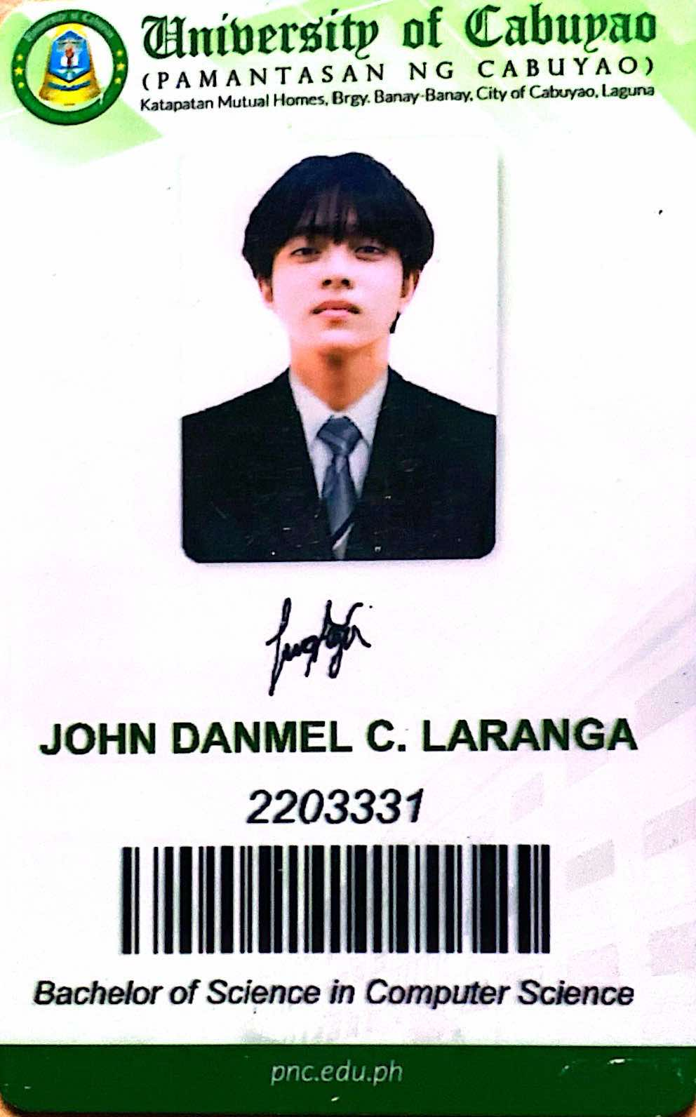

Curriculum Vitae:

https://drive.google.com/file/d/17lV5oYg_DOhIQI077-rFFLXI3eTV2bF0/view

**Darryl John L. Cainday**  
Director for Relations

Student ID:

https://drive.google.com/file/d/1zOX8azUEFWKIZFHl3qhnOp23oqHy9xqD/view?usp=sharing

Curriculum Vitae:

**Mark Achiles G. Flores Jr.**Director for Technology

Student ID:

https://drive.google.com/file/d/15adBpPWHXPqMPPWFbknVlJOSVPgNJIPT/view

Curriculum Vitae:

**Kenneth Hular**  
Director for Learning Clubs

Student ID:

https://drive.google.com/file/d/1y0WS0bSJyMlnFTU4dX4l59xLKsKqn_yv/view?usp=sharing

Curriculum Vitae:

**Cilla C. Adlawan**Director for BuildHers+ Student-Led Initiatives

Student ID:

Curriculum Vitae:

https://drive.google.com/file/d/16HI1wDzg4rvC2nRQBmN9nQ-m-2Nq2Ndv/view?usp=drivesdk